1. **Install python (Any version from 3+)**
   1. Refer INSTALL_PYTHON.docx document for installation steps
2. **Install Notepad++ Editor**
   1. Refer INSTALL_NOTEPAD++.docx document for installation steps
3. **Create PYTHON_WORLD folder in Desktop**
4. **Create a Python file as number.py inside PYTHON_WORLD folder**

**SELECT SAVE AS TYPE ALL TYPE** 

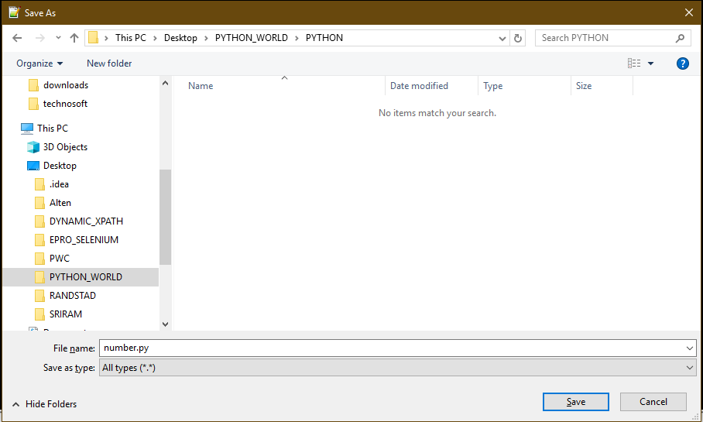

1. **Create a number variable and print**
2. **Execute number.py file in CMD**

**To open command prompt from notepad++**

Right click on file name 🡪 Then Click on “Open Containing folder in cmd”

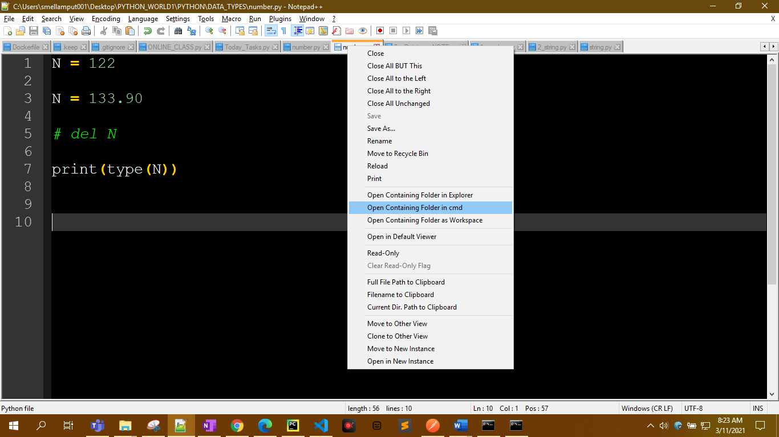

1. **Run Python file like below**

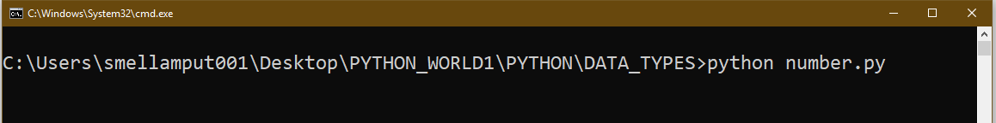

1. **DOWNLOAD FILES FORM WHATSAPP INTO LAPTOP**

Refer WHATSAPP_WEB.docx document for WHATSAPP WEB

1. **TO OPEN PYTHON FILE IN NOTEPAD ++**

**RIGHT CLICK ON PYTHON FILE** THEN CLICK ON **Edit with Notepad++**

